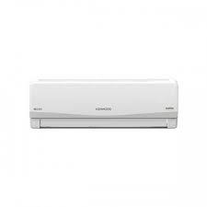

Kenwood Inverter

* Energy Saving
* 18000 BTUs/Hour
* Capacity: 1.5 Ton
* Room Size200 Square FT
* **Rs.77,800**